PathSimR – A&E Example

# Problem

## Project title & summary

Proportion of patient time spent waiting in an emergency department under crisis conditions. This is an example use case, adapted and simplified from a published model.[1]

## Key questions & insights

The main question is how well does a disaster contingency plan – in terms of resource re-allocation between parts of an emergency department – provide resilience to a major event in terms of proportional waiting times for the most seriously ill/injured patients. The major event is modelled in terms of a steep but time-limited increase in arrival rates and the emergency resilience plan is modelled in terms of changes to service rates and capacities at given service points, to reflect the reassignment of doctors and nurses between service points (and potentially the opening of extra treatment rooms and the spreading of doctor/nurse resource between them).

A reference case pathway is specified and what-if analysis then is performed by adding/removing service points of a given type and/or changing capacity and service time parameters within service points, and comparing the resulting differences in mean patient waiting time to total time in system ratios. The comparative effect of the changes on more severe patients is examined by looking at these measures for given service points, as well as for the whole pathway.

## Key PathSimR Features

* High capacity internal queue system
* Rejection at full external queues (patients will be lost if there is no space upon arrival from outside the system)
* Small cycle within the network
* Calendar driven capacity changes (See ‘Shock Room’)
* Multiple external arrival points, each with a unique arrival calendar with a mix of rates

## Summary of services along patient pathway

Patients arrive at the emergency department by different routes and with different severities of illness/injury, and are categorised as “red”, “yellow”, “green”, or “white”. These follow largely discrete pathways through the department and are modelled as having separate arrival rates (in the case of “yellow”, two separate arrival rates depending on the initial service point they are triaged to).

Service points specific to particular arrival rates are named accordingly below. Note also that one of the elements to be modified in the “what-if” analysis could be to vary the number of service points associate with a particular class of arrivals (e.g. adding a second “yellow” emergency room, and splitting the associated “yellow” arrival rates between them), and/or to modify the service rates associated with those units (to represent the effect of sharing fixed human resources between them).

|  |  |  |
| --- | --- | --- |
| Service Point | Service Point Type | Description |
| Shock room (“red”) | A&E Unit | * Capacity changes on a 24 hour cycle   + 8am to 8pm – 6   + 8pm to 8am – 3 * Service time is modelled as a A&E with mean 0.8 |
| Intensive treatment (“red”) | A&E Unit | * Capacity – 4 * Service time is modelled as an A&E with mean = 0.8 |
| Observation room (“yellow”) | A&E Unit | * Capacity – 8 * Service time is modelled as an General Medicine – All with mean = 1 |
| Emergency treatment (“yellow”) | A&E Unit | * Capacity – 5 * Service time is modelled as an A&E with mean = 1 |
| Emergency treatment (“green”) | A&E Unit | * Capacity – 10 * Service time is modelled as an A&E with mean = 1 |
| Examination room | A&E Unit | * Capacity – 5 * Service time is modelled as General Medicine with mean = 0.2 |

## Summary of exits from patient pathway

|  |  |  |
| --- | --- | --- |
| Exit | Possible Discharge Delay | Description |
| Ward admission | Delay – uniform(0.5,0.5) | Admission to a hospital ward, subject to delays due to downstream capacity (not directly measured – to be modelled by a prescribed delay distribution). |
| Discharge | N/A | Exit from the emergency department by discharge, death or other means. |

## External arrival rates to the patient pathway and queue capacity

|  |  |  |
| --- | --- | --- |
| Service Point | Arrival Rate Estimation | Queue Capacity |
| Shock room (“red”) | *Arrival rate changes by hour/6 hour slot*  12am-6am – 0.1725/hour  6am-12pm – 0.345/hour  12pm-6pm – 0.3335/hour  6pm-12am – 0.299/hour | External:0  Internal:0 |
| Intensive treatment (“red”) | N/A | External:0  Internal:0 |
| Observation room (“yellow”) | *Arrival rate changes by hour/6 hour slot*  12am-6am – 0.33/hour  6am-12pm – 0.66/hour  12pm-6pm – 0.638/hour  6pm-12am – 0.572/hour | External: 999  Internal: 0 |
| Emergency treatment (“yellow”) | *Arrival rate changes by hour/6 hour slot*  12am-6am – 0.33/hour  6am-12pm – 0.66/hour  12pm-6pm – 0.638/hour  6pm-12am – 0.572/hour | External: 999  Internal: 999 |
| Emergency treatment (“green”) | *Arrival rate changes by hour/12 hour slot*  8am-8pm – 3.8/hour  8pm-8am – 2.8/hour | External: 999  Internal: 999 |
| Examination room | N/A | External:0  Internal: 9999 |

## Features of the patient pathway

|  |  |  |
| --- | --- | --- |
| Service Point | Onward Service Points or Exits | Additional Information |
| Shock room (“red”) | Intensive treatment – 97.5%  Exit – 2.5% |  |
| Intensive treatment (“red”) | Ward admission: 80%  Examination room: 10%  Exit: 10% |  |
| Observation room (“yellow”) | Emergency treatment (“yellow”): 50%  Ward admission: 25%  Exit: 25% |  |
| Emergency treatment (“yellow”) | Emergency green: 30%  Ward admission: 60%  Exit: 10% |  |
| Emergency treatment (“green”) | Ward admission: 30%  Exit: 70% |  |
| Examination room | Emergency treatment (“yellow”):50%  Emergency treatment (“green”): 10%  Ward admission: 20%  Exit: 20% |  |

## Assumptions and limitations

The published study did not include the service distributions used in their model, only the mean values. For the purposes of this example, the PathSimR Service Distribution Scaling tool has been used to infer possible distributions for each service point by using distributions which fit to available regional data, and then re-scaling to match the given mean service times from the published study. For this example, that has led to the choice of a log-normal distribution for each service point.

This pathway includes a loop between the Emergency Yellow unit and the Examination room. These loops are modelled in the simulation but have an impact on the reliability of the Patient based metrics in the outputs. It is therefore advised that the user only investigate the service point based metrics (Occupancy, Queue Length, # Experiencing Capacity Driven Delays etc) when there is a loop in the system.

# Inputs

## Pathway Figure

Entering the pathway information above into the PathSimR Pathway Wizard, a set of model inputs and a pathway visualisation were automatically created. The pathway diagram (a static version of the tool output is presented in figure 1) serves as a sense check on whether the inputs have been entered correctly, and can inform discussion about what parameters or service point configurations might be varied in what-if analysis.

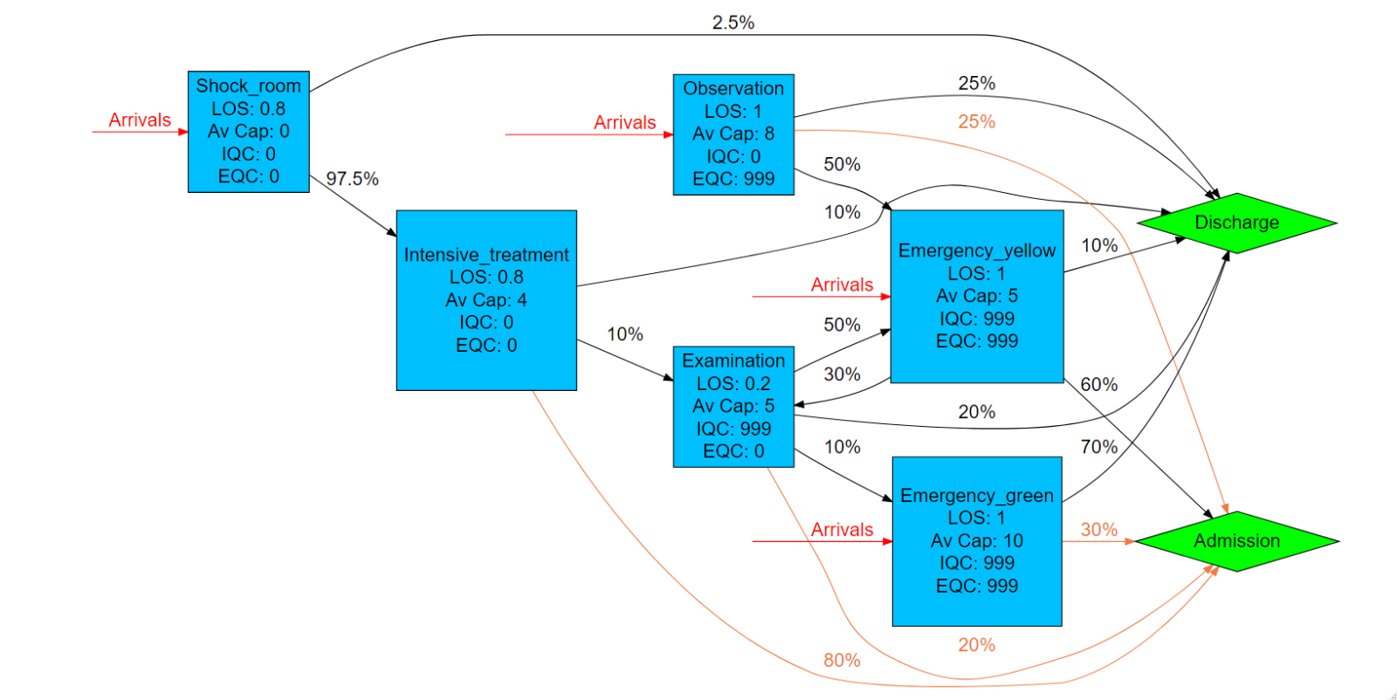

Figure 1

## Input templates

The Pathway Wizard also creates the following two parameter dataframes, which are used to generate the simulation. If the user has entered the data directly into the Pathway Wizard, it can be passed straight to the simulation model without the need for the user to interact directly with these files – but they can be downloaded and saved, then subsequently re-uploaded to PathSimR if the user wishes to run the simulation again without having to re-enter data into the wizard, or if they wish to make changes to specific parameters (e.g. for sensitivity analysis, or “what-if” comparison on the effect of different capacities in given service points).

***Network template***

This template, and extract of which is shown in figure 2, includes transition rates between individual service points and exits, as well as service time parameters and permitted queue lengths for each service point. Note the service points each appear multiple times in the column headers, and the table is truncated at the right.



Figure 2

***Calendar template***

This template, shown in figure 3, includes the arrival schedule (times and associated arrival rates – possibly zero) and the capacity for each service point with a defined capacity and service time.



Figure 3

# Outputs summary

Simulation results for the system described above show substantial under-utilisation at most service points (with the exception of “emergency green”). For example, the “shock room” has an available capacity which varies between 3 and six concurrent patients depending on time of day, but has an average occupancy of only 0.24 patients, and has an occupancy of 1.66 patients or fewer 99% of the time (99th occupancy percentile).

The numerical results are summarised in figure 4 below, and a plot of the results for all service points is shown in figure 5 (note that the “shock room” has capacity to treat 6 patients concurrently between 8am and 8pm, and 2 patients concurrently otherwise, while capacities for all other units are constant over time).

**Numerical occupancy summary**

|  |  |  |  |  |  |  |  |  |
| --- | --- | --- | --- | --- | --- | --- | --- | --- |
|  | **Occupancy percentile** | | | | | | **Average Occupancy** | **Maximum capacity** |
| **node** | **80th** | **85th** | **90th** | **95th** | **99th** | **100th** |  |  |
| **Shock_room** | 0.05 | 0.33 | 0.6 | 0.87 | 1.66 | 4 | 0.24 | 6 |
| **Intensive_treatment** | 0.37 | 0.58 | 0.78 | 0.99 | 1.9 | 4 | 0.34 | 4 |
| **Observation** | 0.83 | 0.98 | 1.38 | 1.83 | 2.81 | 7 | 0.66 | 8 |
| **Emergency_yellow** | 1.34 | 1.62 | 1.9 | 2.53 | 3.68 | 5 | 0.98 | 5 |
| **Emergency_green** | 4.99 | 5.52 | 6.09 | 7.04 | 9.04 | 10 | 3.85 | 10 |
| **Examination** | 0 | 0 | 0 | 0.52 | 0.95 | 4 | 0.10 | 5 |

Figure 4

**Graphical occupancy summary**

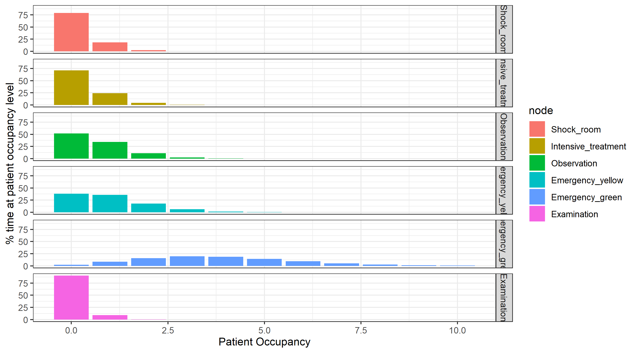

Figure 5

Capacity-driven delays resulting from this pathway setup are negligible (as might be expected given the levels of underutilisation), and the proportion of time delayed awaiting discharge is also small, and mainly concentrated in the “emergency green” service point (note that this directly reflects the specification of prescribed delays to discharge in the pathway description).

Queues are also negligible, with patients only ever queuing at the “emergency yellow” and “emergency green” service points, and queues there being uncommon and small (“emergency yellow” maximum queue size 3, mean queue size 0.003, and no queue at all 99% of the time; “emergency green” maximum queue size 8, mean queue size 0.009, and no queue at all 99% of the time).

1. Cimellaro, Malavisis and Mahin, Using Discrete Event Simulation Models to Evaluate Resilience of an Emergency Department, Journal of Earthquake Engineering, 2016, pp.1-24, doi:10.1080/13632469.2016.1172373